  - 
  - Community Safety Strategic Assessment
Executive Summary
Cannock Chase Strategic Assessment
The Centre for Public Innovation
The Centre for Public Innovation is a Community Interest Company that provides research, training, support and advice in the fields of health, social care, criminal justice and community development.
Our mission is to improve the outcomes of services for their users, with a particular emphasis on the most disadvantaged.
February 2026

Executive Summary

Context
Under the Police and Justice Act 2006 (England & Wales) local authorities are duty-bound to ‘provide evidence-based data to support Community Safety Partnerships (CSPs) in their planning and duties’.
It is a statutory obligation for CSPs to produce an annual localised Strategic Assessment providing a strategic evidence-base that identifies future priorities for the partnership and evaluates year-on-year activity.

Strategic Assessments should be reviewed on an annual basis with a fuller assessment carried out every three years. This Strategic Assessment is a full review and so looks at issues in relation to crime, ASB and other factors in depth. The previous full assessment was undertaken and published in 2021/22.

Strategic Context
The wider framework for addressing crime across Staffordshire is set by the Staffordshire Commissioner’s Office. The Commissioner’s priorities for 2024 to 2028 are:
- An outstanding Police service,
- Supporting victims and witnesses,
- Preventing and protecting
- Impactful partnerships.
Staffordshire Police have also set a number of priorities for 2025 to 2027 which CSPs should seek to align with where appropriate:
- Ensure safe and confident communities,
- Develop an exceptional workforce,
- Develop active and productive partnerships,
- Build an outstanding organisation.

Effects of COVID
The data set out in this report reviews crime and ASB over the period 2022-23 to 2024-25. Data from the period of the COVID-19 pandemic has been intentionally excluded. As with many other facets of life the pandemic had a significant impact on both crime and ASB meaning that the data during and immediately after COVID in no way reflected the norm hence has been excluded.

Overall crime in Cannock Chase
The key finding from this full assessment is that Cannock Chase is a low crime area. Levels of crime have fallen by 9.6% since 2022-23, reflecting a trend occurring across Staffordshire as a whole. Note however that the data indicates a slightly complex picture with a pronounced fall in crime from 2022-23 and a subsequent uptick from 2023-24 to 2024-25. There is nothing in the data to explain the short-term rise.
Levels of crime in Cannock Chase are lower than the rate for the Staffordshire Police force area as a whole and are also lower than the rates for the West Midlands and for England and Wales.
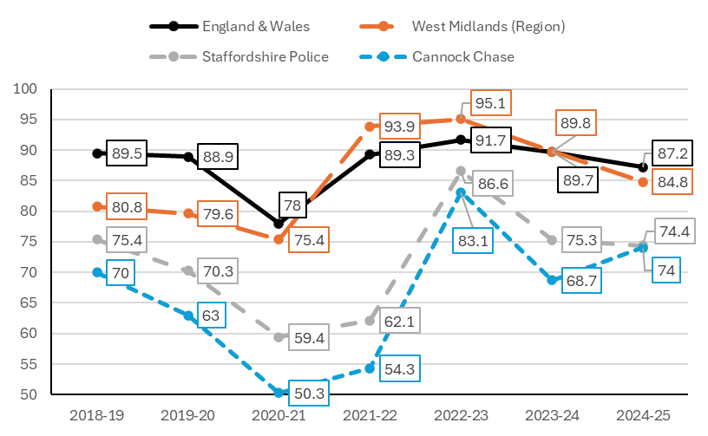
While levels of crime in Cannock Chase are low there is evidently an issue regarding the perception of crime. While only 7% of Cannock respondents to the Police’s perception survey had actually been a victim of crime in the last year, 44% felt that they were likely to become a victim of crime. This has more than doubled since the previous survey in 2024.

We note that the CSP regularly carry out work to promote what they have done and the successes that they are achieving. The data indicates that this work needs to be continued to ensure that messages about crime reach local residents.

Anti-Social Behaviour (ASB)
ASB has consistently been on a downward trajectory with a drop of 33.3% since 2022-23. Moreover the fall in ASB pre-dates the COVID pandemic meaning the trend has been consistent over at least a five-year period. As per crime there has also been a (very slight) uptick in ASB since the period 2023-24.

It is evident from consultation with local stakeholders that ASB is an area of significant focus and activity for the CSP and that swift action is undertaken when ASB does occur. It is clear therefore that ASB is being prioritised locally and addressed.

Key areas of interest

Drug offences
There has been a 21.9% increase in drug offences in Cannock Chase since 2022-23 bringing the rate in Cannock Chase exactly into line with that of Staffordshire as a whole (2.3 per 1,000 of population). The data therefore indicates a growing problem. It is important to contextualise the data on drug offences insofar as the numbers are an increase over a low baseline (192 offences in 2022-23 to 234 in 2024-25).
While actual levels of drug offending are low in terms of total number of offences, drug-related crime was reported as a priority by residents in the Police perception survey.

Possession of weapons
Rates of possession of weapons offences have risen by 64.7% since 2022-23. This is the highest rate of increase for any crime type in Cannock Chase and, at 1.1 per 1,000 of population, gives Cannock Chase a higher rate than for Staffordshire as a whole (0.9).
The data on possession of weapons should be contextualised insofar as absolute numbers are very low, with 112 offences in 2024-25.
While it is possible that rates of increase have been driven by policing and other initiatives and therefore represent better detection rates, levels nonetheless give some cause for concern. The data should also be read in conjunction with data from a pan-Staffordshire survey of young people in which 14% of young people in Cannock Chase thought it normal to carry a knife.

Sexual offences
There has been a 53.9% increase in the rate of sexual offences since 2022-23 with Cannock’s rate (3.7 per 1,000) now above that of Staffordshire as a whole (3.3).
Within sexual offending rates of the most serious offence – specifically rape – have risen by 56.6% with rape constituting around a third of this type of offence.
While numbers of sexual offences remain low in absolute terms (374 offences in 2024-25) the impact on victims is such that this issue warrants further attention.

Shoplifting
There has been a 42.7% increase in the rate of shoplifting in Cannock Chase and the rate (9.1 per 1,000) now exceeds both the West Midlands (8.8) and England & Wales (8.7) rates. Shoplifting now makes up a little under half (43%) of all theft offences, having increased from 27.5% in 2022-23. This indicates that retail crime is a growing problem and that the extent of the growth is outpacing regional and national trends.

Violence with injury
Violence with injury is on a downward trajectory, down by 16.8% since 2022-23.

Consideration of future priorities
Given the data set out in this report we believe that the current priorities for Cannock Chase align well with what partners might wish to include as future priorities. We set out the rationale for each of these.

ASB
Whilst on a downward trajectory ASB is a priority among residents and therefore this in itself warrants ensuring that it is an ongoing priority

Community Cohesion and Tackling Extremism
Whilst numbers of hate crimes are low (154 in 2024-25) there has been an increase of 26.2% since 2022-23.

Drugs and County Lines
While absolute numbers of drug offences are low there has been a pronounced increase in this type of offence over the last three years. Given the accessibility of Cannock Chase via a number of transport routes, the district is likely to remain vulnerable to County Lines activity

Violence
There is a self-evident need to retain violence as a strategic priority in that it constitutes the largest volume of offending, making up 41% of all offending in Cannock Chase.

Theft
Whilst we would suggest retaining this priority, there may be value in focussing on shoplifting which is growing significantly locally and now makes up nearly double the number of the next most common form of theft (vehicle offences).

VAWG
While rates of VAWG and domestic crimes are on a downward trajectory we believe that there is value in retaining a focus on VAWG.

Safeguarding
Issues of safeguarding and vulnerability link many of the priorities above (particularly in relation to domestic abuse and the exploitation of children). Given this, there is evident value in retaining safeguarding as a local strategic priority.

